**CID ने भेष बदलकर किया Mansion का सच उजागर | CID | सी.आई.डी | 16 Nov 2023**

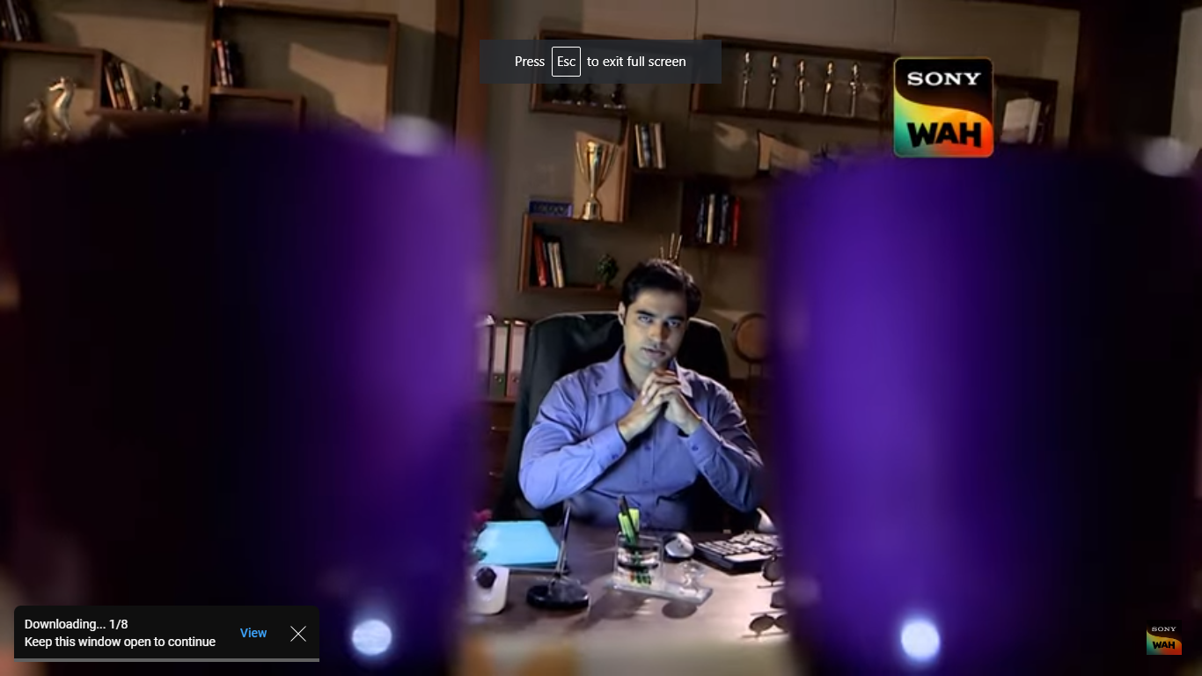

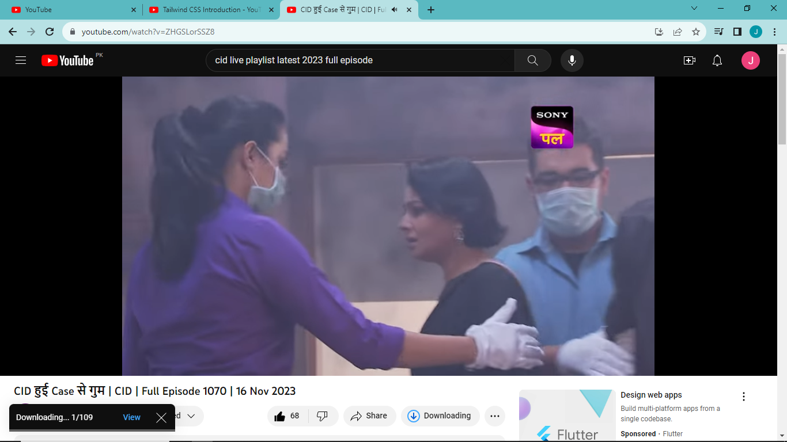

### **Address:**

Crime Investigation Department, Maharashtra State HQ, Near Pune University, Pashan Road, PUNE– 411 008, Maharashtra State, India

### **Contact:**

+91 20 25638444  
Fax - +91 20 25638443  
computer.cid@mahapolice.gov.in  
ig.scrb.pune@mahapolice.gov.in  
adg.cidcrime.pune@mahapolice.gov.in

<https://www.youtube.com/watch?v=71pJVdDx2r4>

@300crore ka Mazak